**INTELLIGENT VEHICLE DAMAGE ASSESSMENT & COST ESTIMATOR FOR INSURANCE COMPANIES**

**Abstraction :**

This problem needs to be resolved due to the rise of fraudulent claims in the insurance sector. Comparing all false claims, auto insurance fraud is the most prevalent. As a result, it is essential to have a system in place to identify and stop this type of fraud, as well as to develop a system to identify insurance fraud. Car insurers can review client claims using our programme more quickly than with other conventional, labor-intensive approaches. Therefore, while the consumer is claiming insurance, our application assists in determining if the claim is legitimate or fraudulent. Compared to conventional approaches, it is more accurate and fraud-free.

**Novelty :**

A collection of ML algorithms with an API that makes use of computer vision make up the Car Damage Recognition system. The algorithms, which are based on deep learning, automatically identify the body of a car and assess the severity of the damage. The analysis process can be accelerated by up to seconds using parallel machine learning and analytical pipelines.

* Identify an automobile.
* Choose the car's components.
* Calculate the cost and preliminary damage to the car's components.

30 seconds for submitting a claim. Machine learning makes it possible to identify damaged auto parts, access damage, anticipate the type of repair that will be required, and calculate the potential cost of the repair.

**Feasibility Of Ideas :**

Companies can offer users an automatic examination of automotive damage thanks to a collection of tools and procedures called car damage assessment. It's crucial since it enables quick damage assessments and repair cost estimates without the need to wait for an inspector.

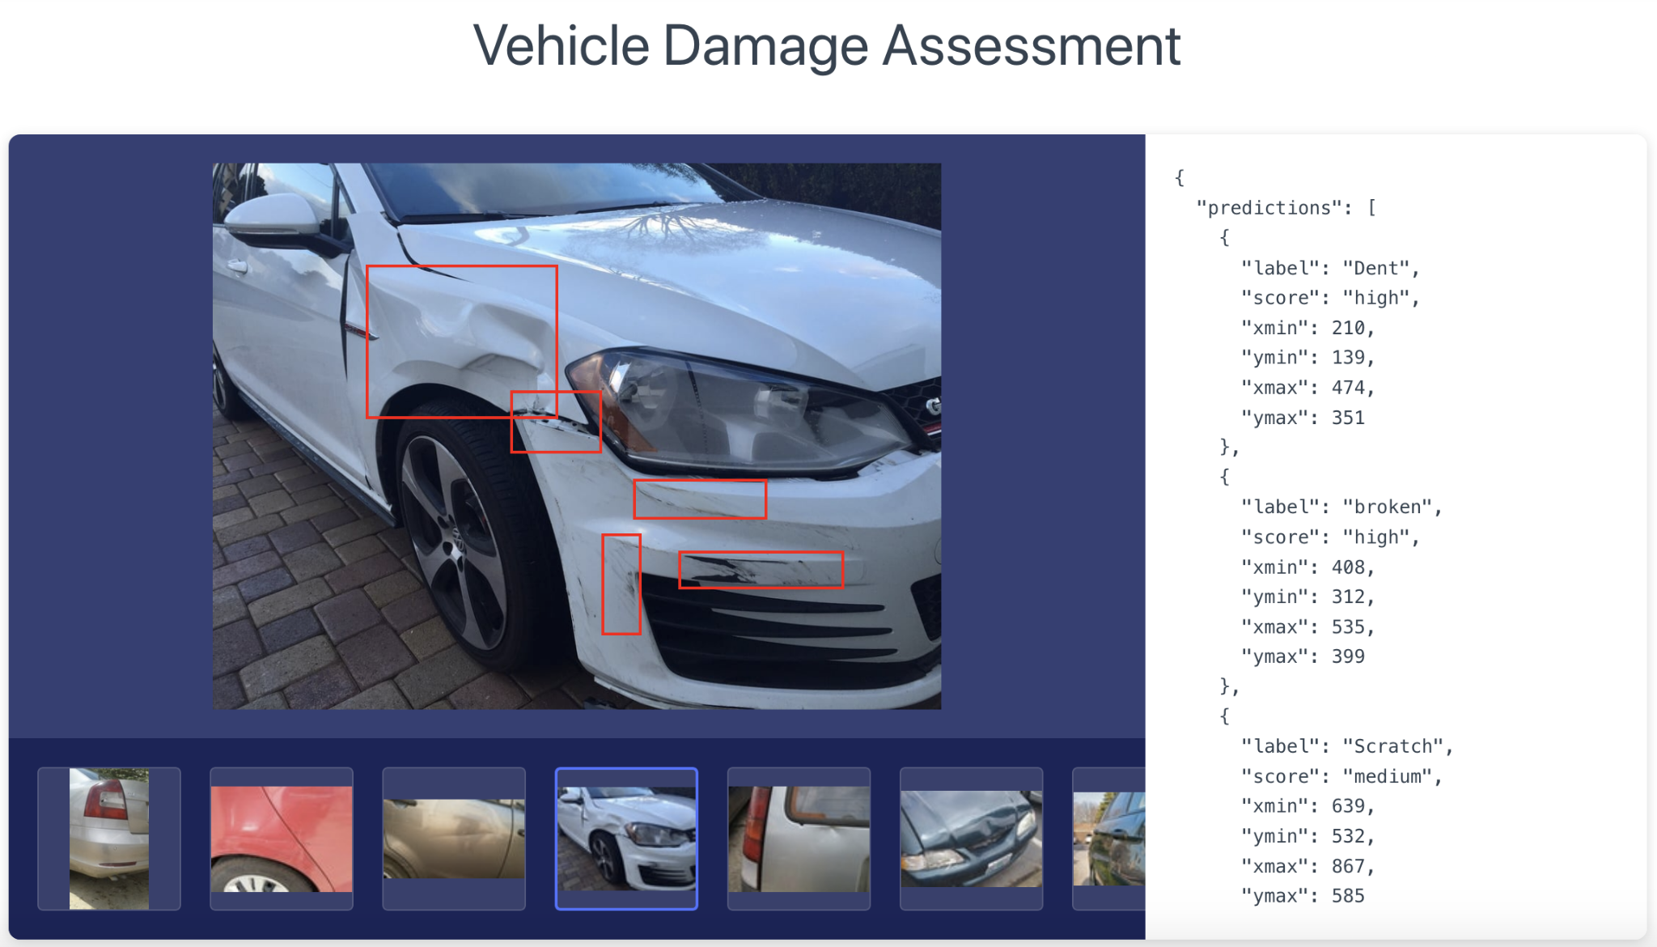

The installation of the required machine learning algorithms and the relevant training data have made vehicle damage detection possible. The following steps are necessary for each insurance claim to be processed:

* Analyze the user-submitted image of the damaged car.
* Examine a vehicle model.
* Consider the angle at which the car is traveling.
* Find faulty auto parts.
* Evaluate the extent of component damage.
* Produce a report.

**Framework for Car-Damage-Detection Algorithms:**

The system for segmenting and detecting vehicle damage was developed in this paper using the Mask RCNN model. The graphic illustrates how an image of the damaged area of the car is chosen and gathered in accordance with the requirements, and how the data are annotated using the LabelMe annotation tool to create a dataset in the json format that is split into a training set and a test set. The data are given to the Mask RCNN for segmentation masking, feature extraction, classification prediction, and automobile damage detection, and the output is the car damage detection result.

**Business Model :**

The approach reduces the amount of time it takes to process data, protects against form fraud (by 80% or more), lowers the cost of hiring new employees, and occasionally speeds up image data analysis. The application is utilized on-site and directs the user's actions to fulfill the photo requirements. Businesses that use Car Damage Recognition replace the time-consuming, human-operated claims processing and approval procedure with analytical technologies and machine learning algorithms.

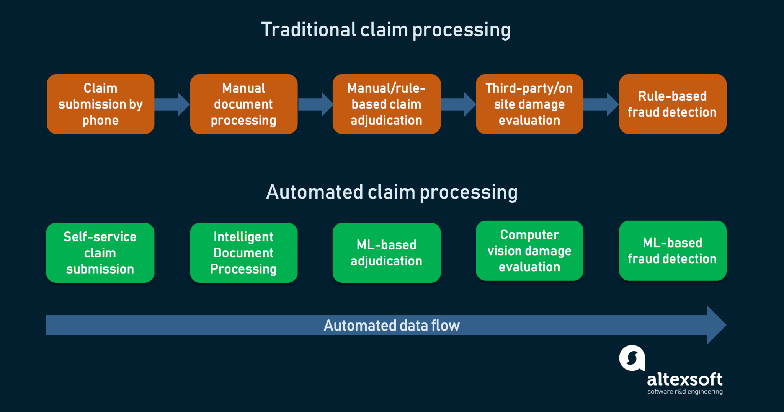

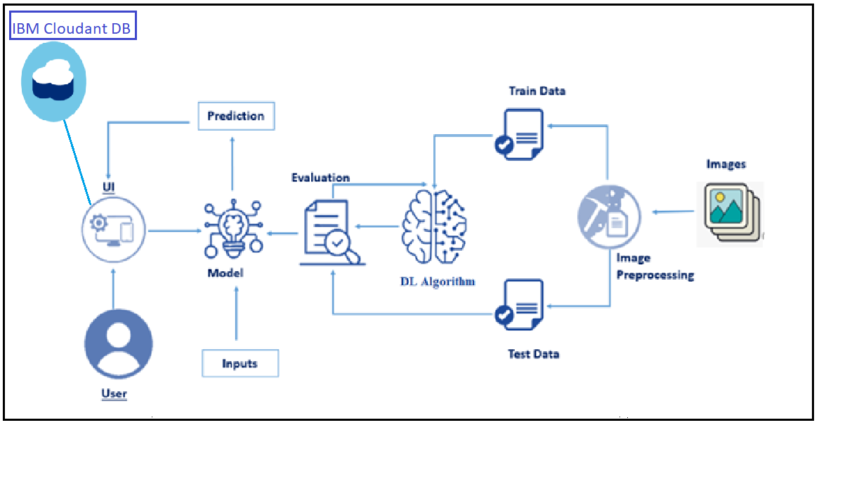

**Scalability :**

enables the scaling of the claim settlement process utilizing an automated framework based on cutting-edge methods and algorithms. The ability to rapidly and affordably fix the faults the system detects benefits insurance companies, car rental businesses, and auto repair shops. We used a number of strategies that had significantly better results than the traditional ones to increase accuracy and speed up the training process. It is crucial to identify the ideal learning rate area because it has a significant impact on the network's efficiency and speed. By increasing the learning rate until the loss stops dropping, as described by Leslie N. Smith's method, a good learning rate bound can be determined. Then, by estimating "acceptable boundaries," we select an ideal learning rate.

They must have the ability to swiftly evaluate and analyze data from multiple sources and offer precise estimates. Analysis and estimation of health harm, medical services, and other factors are also necessary. The client relationships and the reputation of the business will suffer from inaccurate and delayed estimations. You pay for your driving since machine learning-enhanced solutions assist in monitoring drivers' conduct.